**Partners.redbend.com (customers how to)**

**Windows access**

* Install winscp (<https://winscp.net/eng/download.php>)
* Once installed open winscp

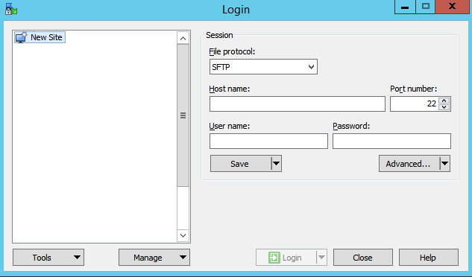

* Click On “New Site”
* 
* change port number to 990
* Insure that File Protocol is set on “Sftp”

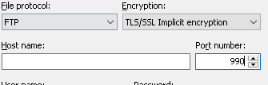

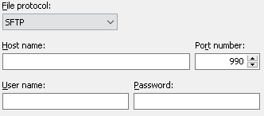

* In the “Host name” Put “partners.redbend.com”
* In the “User name“ box put your Customers Username. In the Password Box, put your Password and click Login.
* 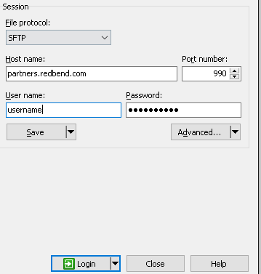
* Once you login you will be presented with a welcome page

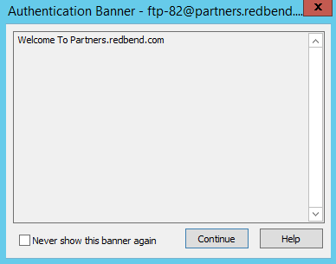

* Click Continue

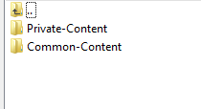

* Private-Content is your customers Private Space
* Common-Content is a Shared space for all customers

All Folders are Read-Only Space

**Linux Access**

* Insure that you have sftp installed , run sftp and you will be presented with command usage

If not installed, install openssh-client

* to connect run the following command ->

sftp -oPort=990 <your-username@partners.redbend.com

* you will be prompt for your password => put in your password
* once connected you will be presented with => Connected to partners.redbend.com
* you have Common-Content and Private-Content
* you can cd to the desired folder
* cd Common-Content
* to list the content run ls
* sftp> ls
* Memeory.xlsx
* To fetch Memeory.xlsx => run mget Memeory.xlsx

sftp> mget Memeory.xlsx

Fetching /Common-Content/Memeory.xlsx to Memeory.xlsx

/Common-Content/Memeory.xlsx 100% 13KB 12.8KB/s 00:00

* When you are done, type “quit”